Service user’s name:
Service user’s ID number/reference/NHS number:
Date of recording:
dd/mm/yyyy
Date of birth:
dd/mm/yyyy
Gender identity:
Name of professional:
Role of professional carrying out evaluation:
Location / site / Clinic:

Making voice recordings
It is recommended that you use Audacity to record. You may also record directly into Praat.
- Sustained [ɑː] for at least 6 seconds
- Rainbow Passage
https://www.york.ac.uk/media/languageandlinguistics/documents/currentstudents/linguisticsresources/Standardised-reading.pdf
- Consider asking the service user to sing ‘Happy Birthday to You’ to hear pitch changes.

See:
Pert, S. (2023). Making a voice recording and evaluating the vocal frequency (pitch) and sound pressure level (loudness). https://www.speechtherapy.co.uk/page-19/page-14/
Curtis, J. (2022). Tutorials: Voice. https://www.jamescurtisphd.me/tutorials/voice/acoustic-analysis-of-voice

Fundamental frequency
Praat: Highlight sound fileView and EditHighlight section to be analysed
- Pulses Voice report OR
- PitchGet pitch / Get minimum pitch / Get maximum pitch
Speech analysed: | Sustained [ɑː] - 2-3 second middle segment  Rainbow Passage
Mean pitch: | Hz
Minimum pitch: | Hz
Maximum pitch: | Hz
Pitch range: (For connected speech) | Hz
Observations/Comments:

- The cismale range is approximately 100-140 Hz
- The gender-neutral range is approximately 145-175 Hz
- The cisfemale range is approximately 180-220 Hz
  - (Davies, 2015, p. 122)

Sound Pressure Level – Loudness
Praat: Highlight sound fileView and EditHighlight section to be analysed
- IntensityGet intensity / Get minimum intensity / Get maximum intensity
Speech analysed:
Intensity Mean: | dB
Minimum intensity: | dB
Maximum intensity: | dB
Intensity range: (For connected speech) | dB
Observations/Comments:

Table 2. Intensity of speech – Conversational Intensity Levels (CIL)
Second and third sentences of the Rainbow Passage recorded at 30 cm from the speaker.
Group | Mean CIL (dB) | Standard deviation | Range (dB)
Both genders | 68.65 | 2.85 | 60.21 to 77.72
Cis males | 69.53 | 2.77 | 60.59 to 79.00
Cis females | 67.77 | 2.71 | 59.82 to 76.44
(N=20 males, 20 females, trial 1 data)
(After Pausewang Gelfer & Ryan Young, 1997)

Voice Disorder Screening: Smoothed Cepstral Peak Prominence (CPPS)
Requires installation of the free plug-in: https://osf.io/t5hrv/ (Heller-Murray, 2022)
Praat: Highlight sound fileCalculate CPPS >Single file…OK
Speech analysed: | Sustained [ɑː] - 2-3 second middle segment  Second sentence of the Rainbow Passage
CPPS graph:  Praat: Praat PictureSave as 600-dpi PNG file…filename  Microsoft Word: click on the picture on the right to replaceInsertPictures=Picture from FileSelect file saved in PraatResize | 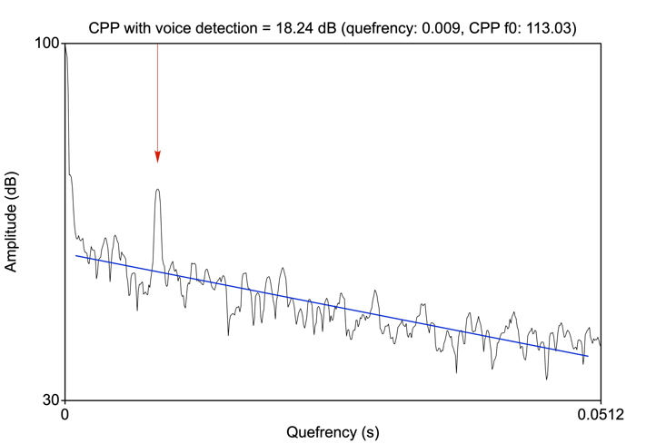
CCPPS with voice detection value:
CPPS is <14.45 dB for [ɑː] vowel: | Yes – voice disorder suspected  No – voice disorder not suspected
CPPS is <9.33 dB for connected speech: | Yes – voice disorder suspected  No – voice disorder not suspected
Observations/Comments/Actions:
Please accompany with subjective evaluations and
refer to clinical guidelines on voice evaluation.

References
Boersma, P. and Weenink, D. (2023). Praat: doing phonetics by computer [Computer program]. Version 6.3.09, retrieved 2 March 2023 from http://www.praat.org/
Curtis, J. (2022, 6th April 2023). Tutorials: Voice. https://www.jamescurtisphd.me/tutorials/voice
Davies, S., Papp, V. G., & Antoni, C. (2015). Voice and Communication Change for Gender Nonconforming Individuals: Giving Voice to the Person Inside. International Journal of Transgenderism, 16(3), 117-159. https://doi.org/10.1080/15532739.2015.1075931
Heller Murray, E. (2022). Cepstral Peak Prominence – Praat with and without voice detection. https://osf.io/t5hrv/
Pausewang Geifer, M. & Young, S. R. (1997). Comparisons of intensity measures and their stability in male and female speakers. Journal of Voice, 11(2), 178-186. https://doi.org/10.1016/S0892-1997(97)80076-8
Pert, S. (2023). Making a voice recording and evaluating the vocal frequency (pitch) and sound pressure level (loudness). https://www.speechtherapy.co.uk/page-19/page-14/

Clinical guidelines
American Speech-Language-Hearing Association (ASHA) (2023). Voice Disorders. https://www.asha.org/practice-portal/clinical-topics/voice-disorders/
Royal College of Speech and Language Therapists (RCSLT)(2023). Voice – guidance: Assessment. https://www.rcslt.org/members/clinical-guidance/voice/voice-guidance/#section-7

